Surname and Initials:  Reyneke, R  ………………………………………………… | Session Day:  ………………  Wednesday | Group no  …………  6
Student number: 21495034


DEPARTMENT OF PHYSICS
FSK 116
Practical Report
AMO – Accelerated Motion

Part 1: EXPERIMENT
- Introduction
In this experiment, you will determine the time, t, it takes for a block to slide certain distances, s, down an inclined surface. Graphing the measurements will then enable you to analyze the motion of the block quantitatively.
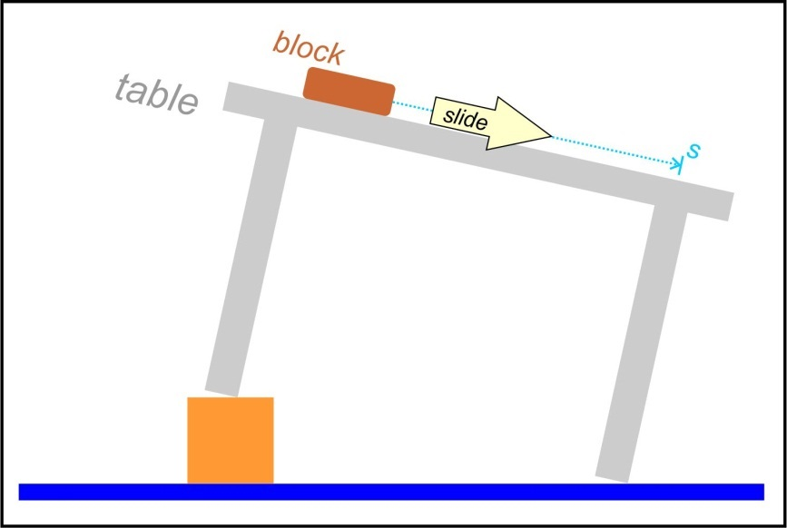
Figure 1 A block slides down the surface of a table that is setup at an angle.

- Set-up
Let the hunt begin! 
Any long smooth flat surface that is not bowed can be used, a shelf, removable door or even a corrugated roof sheet might work in which case you can use a ball instead of the block. It should be at least one meter long.
Next you need to set the surface up so that it is sloping downwards and then search for an item that slides or rolls down the surface in a straight line. The speed should increase smoothly as it motions downwards. You will need to cushion it’s fall when it drops off the end of the surface if the object is breakable. A box with a towel draped over the opening might work or any other soft object like a duvet. Change the incline of the surface if necessary. The motion should not be too fast.
- Doing the experiment
Next, you need to determine the time it takes for the “block” (mug, pencil box, ball …) to slide (roll) through various distances down the incline, as shown in figure 2. I found it difficult to time it with the stopwatch on my phone and decided to rather make a video and determine the time intervals from the video. The problem with the stopwatch on the phone was that I needed to switch between looking at the screen of my phone and watching the motion of the block. You can try timing it with the stopwatch on your phone by holding the screen a bit to the side of where you are viewing the sliding block. The best is to use the lap function of the stopwatch as the block passes the marks on the incline.

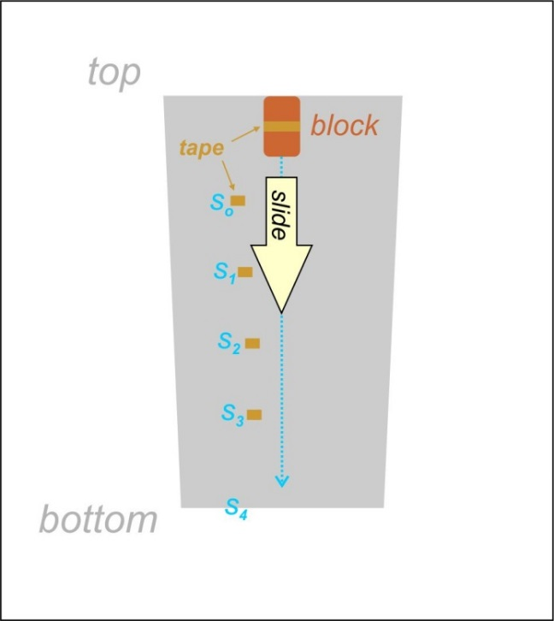
Figure 2: Viewing the downwards sloping surface face-on.

The block starts out of rest at the top. I held a broom in front of it and quickly removed it downwards to start the motion. Start the stopwatch first and then release the block. When the block passes the s_{o} mark, the lap button is pressed and also as it passes the other marks, s_{1,} s_{2,} s₃, and finally when it drops of the bottom of the surface, s₄. Only thereafter the stopwatch is stopped. If you find it too challenging to time the motion this way you can make a video of the motion as explained in the next section, but read the paragraphs below in any case.
Measure the distances from s_{o} up to the other four positions s_{1,} s_{2,} s₃ and s₄. You can join strips of newspaper or sheets together with tape to cover the distances and measure along the straight edge of the joined strips.
Your data will then be the following distances:
- s_{o} up to s₁, which you can label as s₁
- s_{o} up to s_{2,} which you can label as s₂
- s_{o} up to s_{3,} which you can label as s₃, and
- s_{o} up to s₄, which you can label as s₄
See figure 3, and the times for the block to cover these distances. The lap function of the stopwatch saves the stopwatch reading each time you press the button.
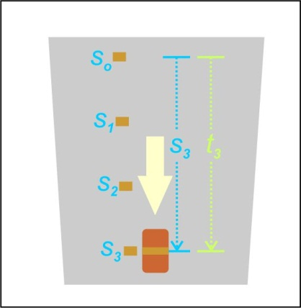
Figure 3: The third set of measurements

- Making a video of the motion
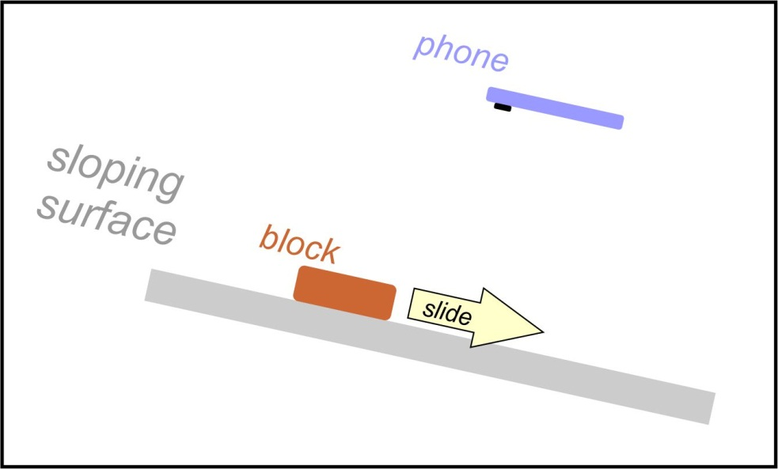
Make a video of the motion and determine the times from it. You should hold your phone in a stationary position about halfway down the surface. Hold the phone at the same angle as the sloping surface and keep it still while the object is sliding down – see figure 4 (If you know how to edit the video remove the unnecessary parts at the beginning and end of the video. That will make the edited version a smaller file which will upload quicker as explained in the next session.)
Figure 4: Using your phone to record the motion

- Determining the times from the video
- First upload the video to your youtube.com account by clicking on the icon at the top right of the page -  .
- Copy the link to the video in the address field at the top of the page – youtube.com/watch?v= …… onto the clipboard.
- Go to the webpage watchframebyframe.com and paste the copied link into the region where it says ENTER VIDEO URL OR ID
- Click on WATCH VIDEO next to the entry box.

- Now play your video on that webpage: Click on the play button at the bottom left of the video (that is the white triangle pointing to the right), and then quickly click on the pause button (the two vertical white lines that show up in the same spot where the play button was). Close the suggested videos that appear over your video by clicking on the X symbol at their top right.
- Step through the individual frames of your video and read off the times at which the block is next to the s_{o,} s_{1,} s_{2,} s₃, and s₄ positions – see figure 5. You can move forward or backward through the frames in the video by dragging the right-hand end of the red slider to the right or left. Changing the fps (frames per second) does not alter the obtained times significantly. Your video was most likely recorded at 30 fps. You can use the Video Info Viewer App to check yours if you want to.
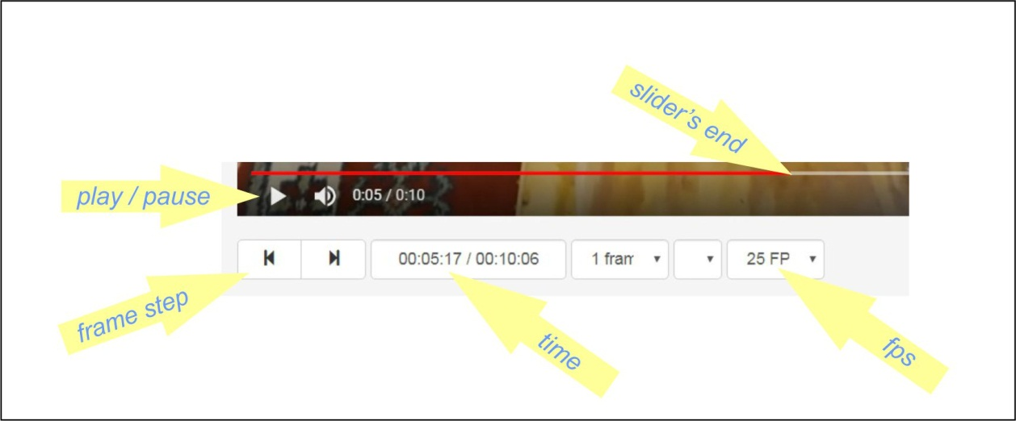
Figure 5 The video controls on watchframebyframe.com

The three parts of the time display and their significance is displayed in the following picture
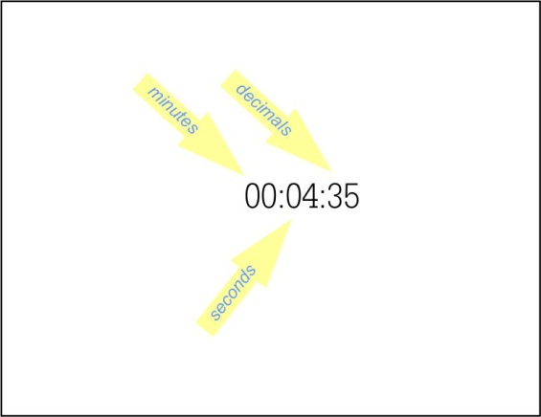
Figure 6 The displayed video time on watchframebyframe.com , 4.35 seconds in this example.
Use these readings to determine the times it took the block to cover the s_{o,} s_{1,} s_{2,} s₃, and s₄ distances. As shown in the example in figure 3.
Having problems getting watchframebyframe to do what you want it to do? Do not worry! That is normal! 
Here are two suggestions to try to get it to behave:
- Refresh the page to the left of the url or address field at the top right region of the page 
- Start over by going to the homepage of watchframebyframe – click on 

INSERT PHOTOGRAPH OF YOUR EXPERIMENTAL SETUP HERE
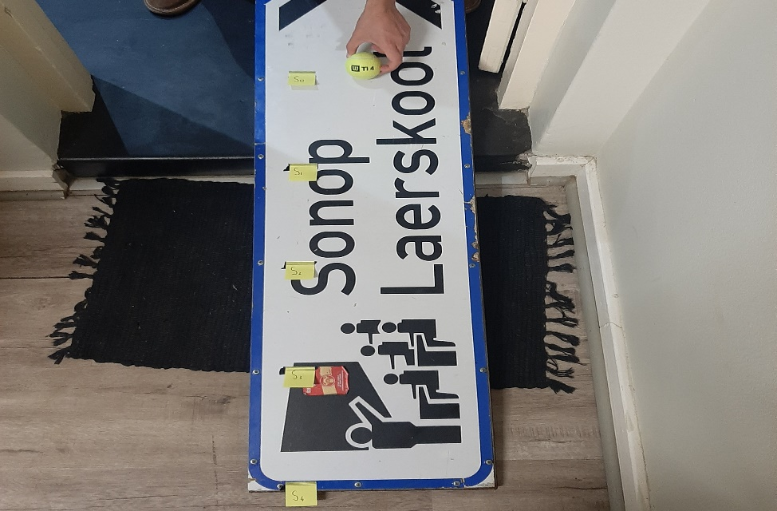
Part 2: DATA ANALYSIS
EXPERIMENTAL AIM:
The aim of this experiment is to determine the time, t, it takes for a block to slide certain distances, s, down an inclined surface. Consequently, to analyze the motion of the block quantitatively using these values in a graph.

Next, you can analyze your data using a graph and obtain the relationship between the variables and the general equation of motion of the block down the surface.
- Tabulate
Tabulate your results, the s distances, and the time it took the block to cover these distances together with the calculated values of $\frac{s}{t}$, that is the average speed over each of the distances. Supply units for the values and be realistic about your significant digits for the values. (Remember to use the correct format for column headings!)
Title: The distances (s, in meter) and time (t, in seconds) it took the object to reach these distances, as well as the average speed (s/t, in m/s) of the object.

 | s | t | $\frac{s}{t}$
S₁ | 0.25 | 0.68 | 0.37
S₂ | 0.50 | 1.04 | 0.48
S₃ | 0.75 | 1.35 | 0.56
S₄ | 1.00 | 1.56 | 0.64

- Draw a graph
- Plot a graph of the average speed, $\frac{s}{t}$, as a function of time. Remember, your graph does not have to start at zero, but rather a somewhat smaller value than your minimum value.

- Calculate the gradient of the graph. (Show the gradient triangle on your graph)

- What is the y-intercept, $y_{o}$? (Indicate the intercept on the graph)

- Write down the empirical equation of the graph, with units for the constants in the equation.

- Equation of motion
If we multiply the empirical equation with time, $t$, we obtain an equation of the form
$$s=grad t^{2}+ y_{o}t…………(2)$$

Question 1 What is the physical meaning of the y-intercept, $y_{o}?$

Question 2 What are the units of the gradient?

Question 3 What kinematic quantity has the same units?

Compare equation 2 to the kinematic equation
$$s=ut+ \frac{1}{2 } at^{2}…………(3)$$
Question 4 What could $u$ in equation 3 possibly correspond to in this experiment?

Question 5 What can the gradient of the graph possibly correspond to in equation 3?

Question 6 If so, what is the corresponding value and units of $a$ in equation 3 according to this experiment?

CONCLUSION

GRAPH PAPER
